National University of Computer and Emerging Sciences Islamabad Programming Fundamentals Lab FALL 2022

**Lab Manual 06**

# Cmath

The C++ <cmath> header file declares a set of functions to perform mathematical operations such as: sqrt () to calculate the square root, log () to find natural logarithm of a number etc.

Below are some functions declare in cmath library:

# Ceil ()

The ceil () function in C++ returns the smallest possible integer value which is greater than or equal to the given argument.

## Syntax:

|  |
| --- |
| **ceil (num);** |
| * num - floating-point number whose ceiling value is to be computed * Return - the smallest possible integer value which is greater than or equal to num. |

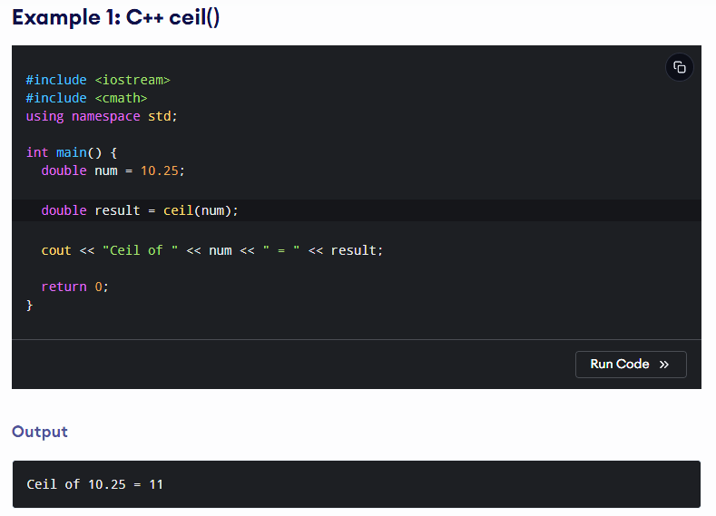



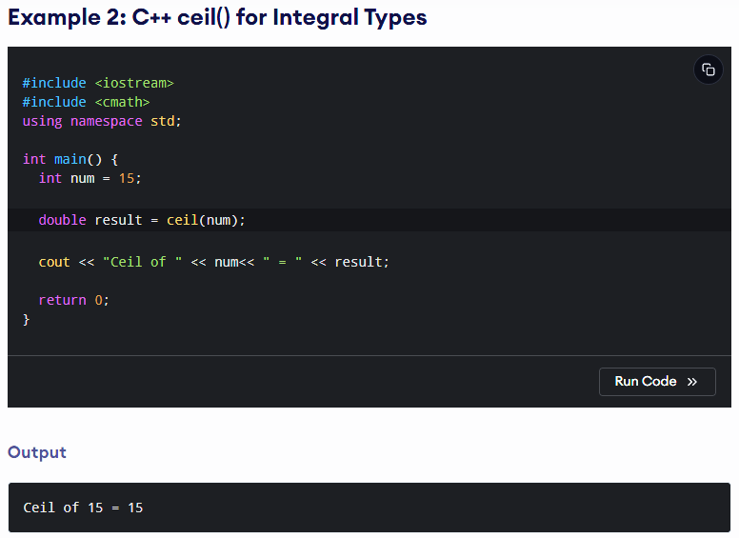



# Floor ()

The floor () function in C++ returns the largest possible integer value which is less than or equal to the given argument.

## Syntax:

|  |
| --- |
| **floor (num);** |
| * num - floating-point number whose floor value is to be computed * Return - the largest possible integer value which is less than or equal to num. |

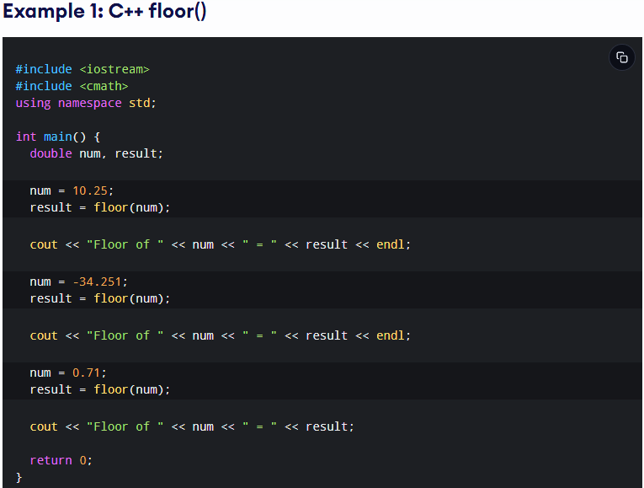

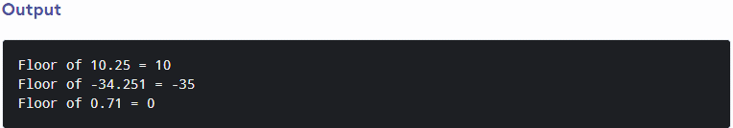

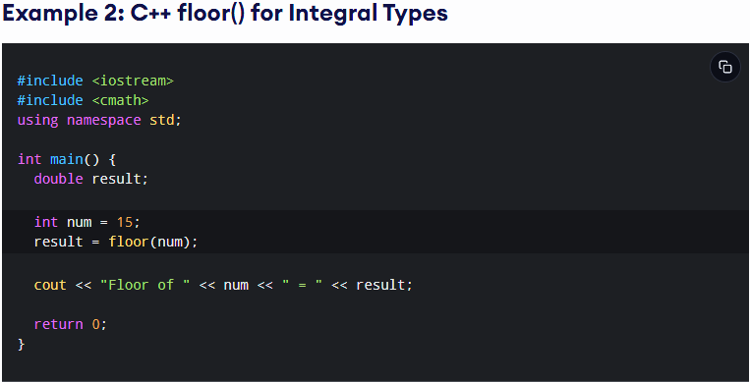



# Pow ()

The pow () function returns the result of the first argument raised to the power of the second argument.

## Syntax:

|  |
| --- |
| **pow (base, exponent);** |
| * base - the base value. * exponent - exponent of the base. * Return - the result of base exponent OR 1.0 if exponent is zero OR 0.0 if base is zero |

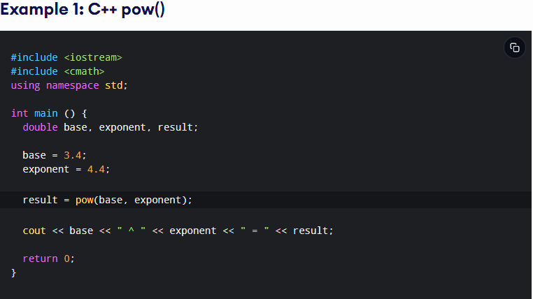

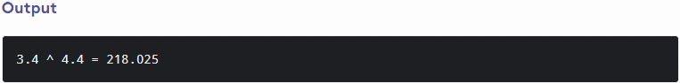

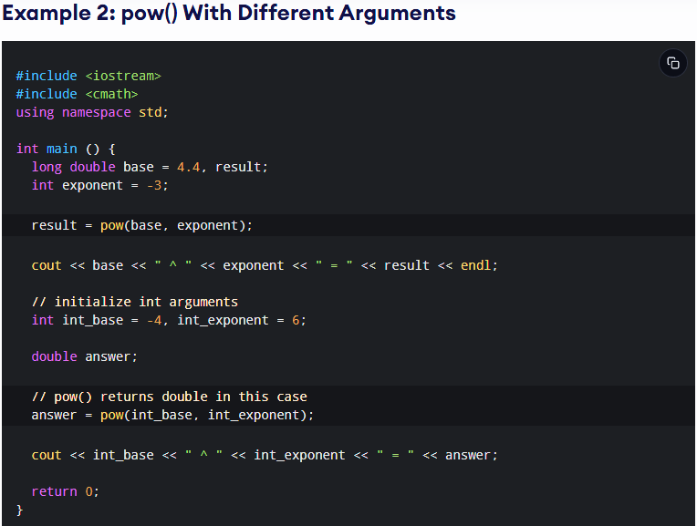

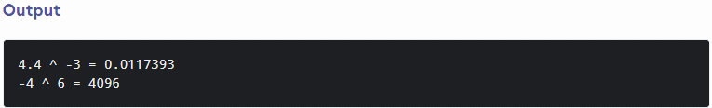

# Sqrt ()

The sqrt () function in C++ returns the square root of a number.

## Syntax:

|  |
| --- |
| **sqrt (num);** |
| * num - a non-negative number whose square root is to be computed * Return - the square root of the given argument |

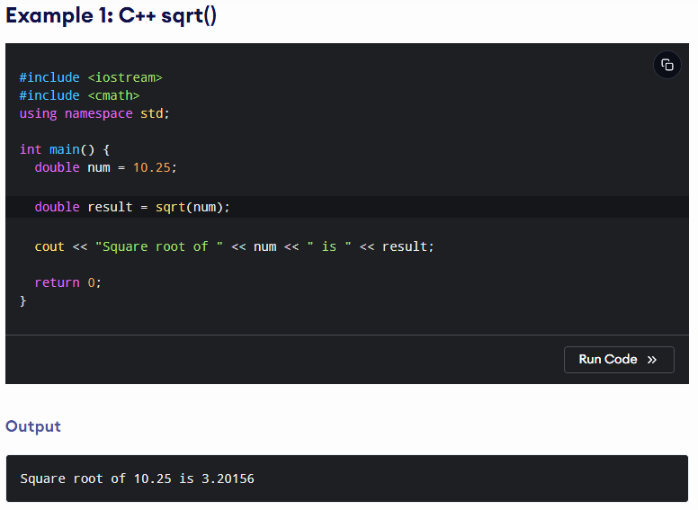



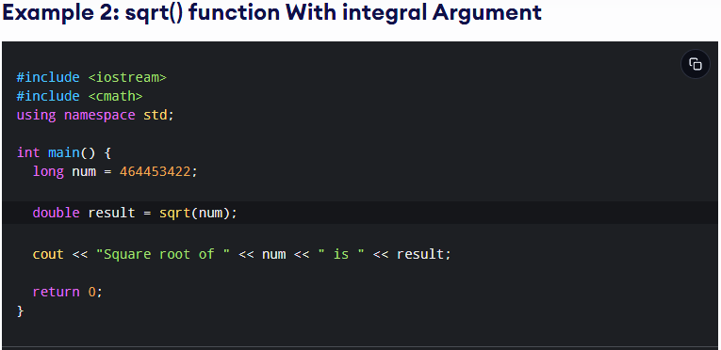

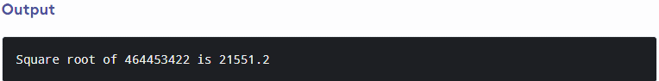

# Static Cast

The static_cast is used for the normal/ordinary type conversion. This is also the cast responsible for implicit type coercion and can also be called explicitly. You should use it in cases like converting float to int, char to int, etc.

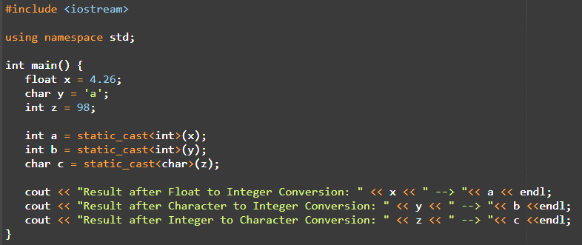

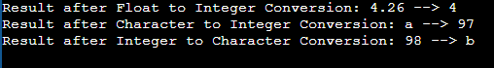

## Problem 01

Write a **Pseudo cod** that take number as an input from user and find the factor of that number.

## Problem 02

Write a **C++ code** that take 5 digit number as an input from user then display each digit separately.

**For Example**

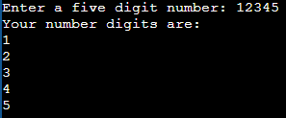

## Problem 03

The radius of the aorta is about 1.0 cm and the blood flowing through it has a speed of about 30 cms-1. Calculate the average speed of the blood in the capillaries using the fact that although each capillary has a diameter of about 8 x 10-4 cm, there are literally millions of them so that their total cross section is about 2000 cm². (**CPP code**)

**Hint: Use equation of continuity**